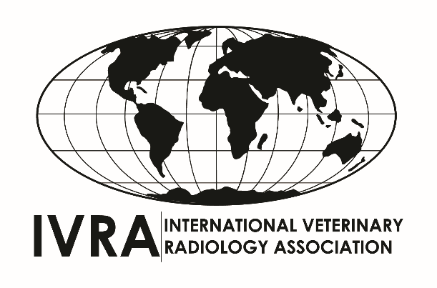
2026 IVRA BERNSTEIN CONFERENCE FELLOWSHIP

https://www.ivraimaging.org

Conference Fellowships have been established by the International Veterinary Radiology Association to support travel to IVRA meetings, which are held every three years.
The objective of each fellowship is to provide financial support up to a maximum of US $5,000 for veterinarians from countries which have limited or no funding for the applicant to attend the meeting and who wish to present a scientific paper (oral or poster) at the meeting 12-16 July 2026 in Fukuoka, Japan.

Applicants must complete the application form in English and also send:

1) A brief curriculum vitae of your publications and other merits such as grants awarded and lectures given, giving details of your work performed in the field of veterinary radiology (diagnostic imaging) or related subjects (maximum 3 pages).
2) A scientific abstract, in English (no more than 500 words), of the paper to be presented at the scientific meeting of IVRA 2026. The abstract must follow the format: Introduction/purpose; Materials and methods; Results; Discussion and Conclusions.

3) Electronic submission is required. The application form can be downloaded from the association website at https://www.ivraimaging.org

APPLICATIONS MUST BE RECEIVED BY 31st December 2025

Applications must be sent electronically to: ruth.dennis.vet@gmail.com

You will be notified of the result by 31st January 2026.

APPLICATION FORM
(Please type, or print clearly)

Family name:

Given name:
[ ] male [ ] female

Postal address:
Languages spoken (in order of fluency):

University and year from which veterinary degree obtained:

Qualifications (degrees or diplomas) after veterinary degree:

Appointments (employers, your position and dates) since graduation from veterinary school (e.g. assistant professor, University of xx, 2009 - 2011)

What other financial assistance (amount and source) for travel to IVRA 2026 is available to you in your country?

List items for which you are claiming from IVRA:
1) air fare, other travel
2) conference
registration
3) hotel lodging
4) daily expense allowance (where applicable)

Detail of previous attendance at conferences or diagnostic imaging externships outside your country in the last five years:

Have you previously received an IVRA fellowship or grant? If yes please provide details.

Visa – do you anticipate needing a visa to enter Japan, and can you be sure of getting one in time, after 31st January?

How much money (US$) are you seeking from IVRA?

Title of proposed presentation at IVRA 2026:
Oral / Poster / Either
(delete as applicable)

How would the award of the fellowship improve the development of veterinary radiology in your country?

Phone number (s):
(country code & number)

Fax Number:

Email address:
Date of submission:

SIGNATURE

Please also send your curriculum vitae and the abstract (a copy of the institutional ethical committee’s approval of the project must be included).

